Networking Lab 5

VNet Peering

Transitive Behavior

Lab Overview

Now that we have successfully setup a virtual network peering, let’s see how transitive peering works.

Lab Diagram

Create a virtual network vnet2

We will use CLI to create a virtual network vnet2, add a subnet vnet2-subnet1 and add a virtual machine vnet2-vm1 in the subnet.

Define the following variables and run the command to create a virtual network vnet2, with one subnet vnet2-subnet1.

ResourceGroup=rg-lab

VnetName=vnet2

VnetPrefix=10.2.0.0/16

SubnetName=vnet2-subnet1

SubnetPrefix=10.2.1.0/24

Location=westus2

az network vnet create -g $ResourceGroup -n $VnetName --address-prefix $VnetPrefix --subnet-name $SubnetName --subnet-prefix $SubnetPrefix -l $Location

Attach the network security group to vnet2-subnet1

Nsg=nsg1

az network vnet subnet update -g $ResourceGroup -n $SubnetName --vnet-name $VnetName --network-security-group $Nsg

Create a virtual machine

VmName=vnet2-vm1

SubnetName=vnet2-subnet1

AdminUser=azureuser

AdminPassword=Azure123456!

az vm create --resource-group $ResourceGroup --name $VmName --image UbuntuLTS --vnet-name $VnetName --subnet $SubnetName --admin-username $AdminUser --admin-password $AdminPassword

**Note:** The above parameters provide a username and password for simplicity. Please create a user with a strong password known only to you!

Peer virtual networks

Next, let’s peer virtual networks vnet-hub and vnet2.

1. In the Search box at the top of the Azure portal, begin typing *vnet2*. When **vnet2** appears in the search results, select it.
2. Go to **Settings** 🡪 **Peerings**, and then select **+ Add**, as shown in the following picture:

E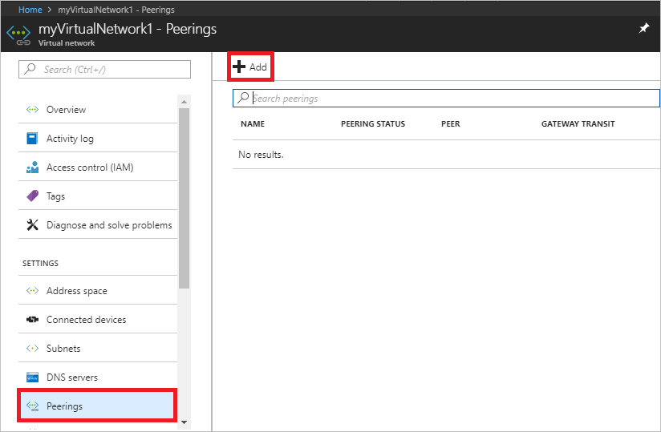

1. Enter, or select, the following information, accept the defaults for the remaining settings, and then select **OK**.

|  |  |
| --- | --- |
| **Setting** | **Value** |
| Name of the peering from vne1 to remote virtual network | peer-vnet2-to-vnet-hub |
| Subscription | Select your subscription. |
| Virtual network | Select 'vnet-hub' from the list. |
| Name of the peering from vnet-hub to vnet1 | peer-vnet-hub-to-vnet2 |
| Allow forwarded traffic from vnet1 to vnet-hub | Enabled |
| Allow forwarded traffic from vnet-hub to vnet1 | Enabled |

Verify the peering status. This should show as Connected.

Verify the routes in vnet2.

Go to the virtual machine vnet2-vm1 page and go to **Settings** 🡪 **Networking** tab.

Click on the network interface name and go to **Support + troubleshooting** 🡪 **Effective Routes**. You should be able to see a route to the vnet-hub network 10.0.0.0/16 with Next Hop Type as VNet Peering.

Verify reachability between the peered vnets:

Let’s try to reach virtual machines across the two peers.

1. From the Azure portal, go to the **Virtual machines** page.
2. Note the Public IP of VM **vnet2-vm1**.
3. Note the private IP of VM **vnet-hub-vm1**.
4. Connect to virtual machine **vnet2-vm1** using its public IP.

ssh <username>@<Public_IP_of_VM>

1. Ping private IP of virtual machine vnet-hub-vm1.
2. Verify pings are successful.

Transitive Peering

So far, we have a hub and spoke topology where we have vnet-hub connected to vnet1 and vnet-hub also connected to vnet2. Note that vnet1 and vnet2 are not directly peered. Let’s check connectivity between virtual networks vnet1 and vnet2.

1. From the Azure portal, go to the **Virtual machines** page.
2. Note the Public IP of VM **vnet2-vm1**.
3. Note the private IP of VM **vnet1-vm-mgmt1**.
4. Connect to virtual machine **vnet2-vm1** using its public IP.

ssh <username>@<Public_IP_of_VM>

1. Ping private IP of virtual machine vnet1-vm-mgmt1.

Were you able to ping successfully?

Conclusion

The connectivity between vnet1 and vnet2 does not work because transitive peering is not allowed.